**LAB # 03**



**CSE102L Computer Programming Lab**

Submitted by: **MAAZ Habib**

Registration No. :**20PWCSE1952**

Class Section:**C**

“On my honor, as student of University of Engineering and Technology, I have neither given nor received unauthorized assistance on this academic work.”

Submitted to:

**Engr. Abdullah Hamid**

Month Day, Year (06,29,2021)

Department of Computer Systems Engineering

University of Engineering and Technology, Peshawar

**Lab # 8**

**Objectives:**

To understand pointers and references.

Hint: You can also input values in pointers using cin&gt;&gt;*p;

**Tasks:**

**1.** Write a C++ program where you take two values in two variables from user, add the values of the two variables and put it into a third variable using a pointer. you must you only one pointer.

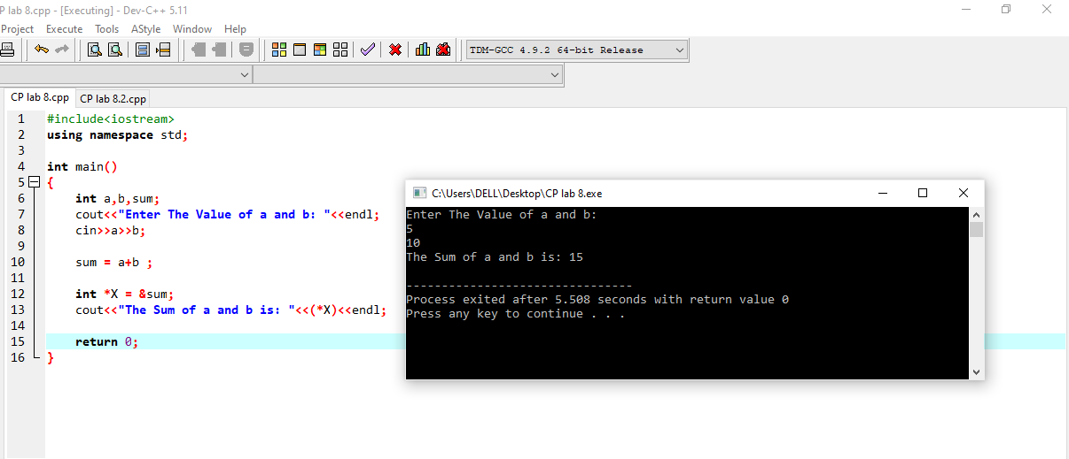

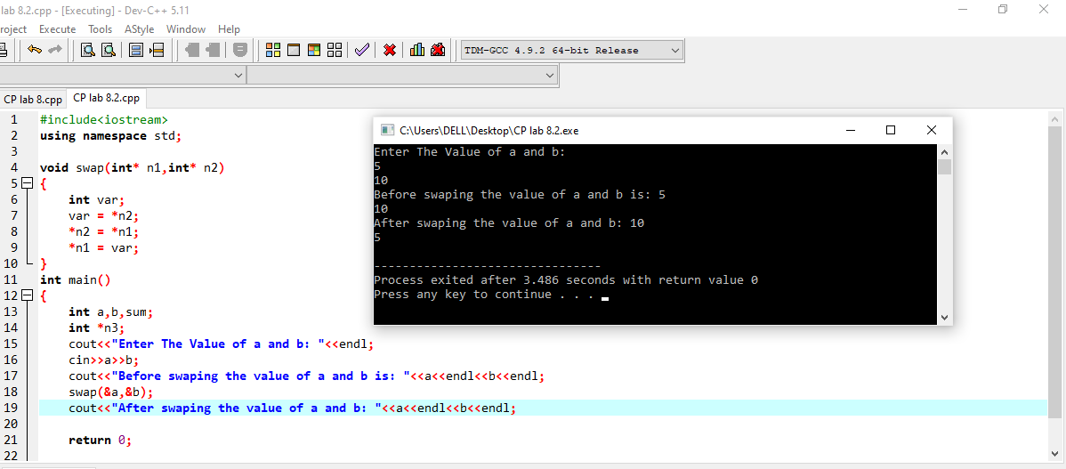**2.** Write a C++ program where you take two values from user in two variables, swaps the values of the variables using pointers.

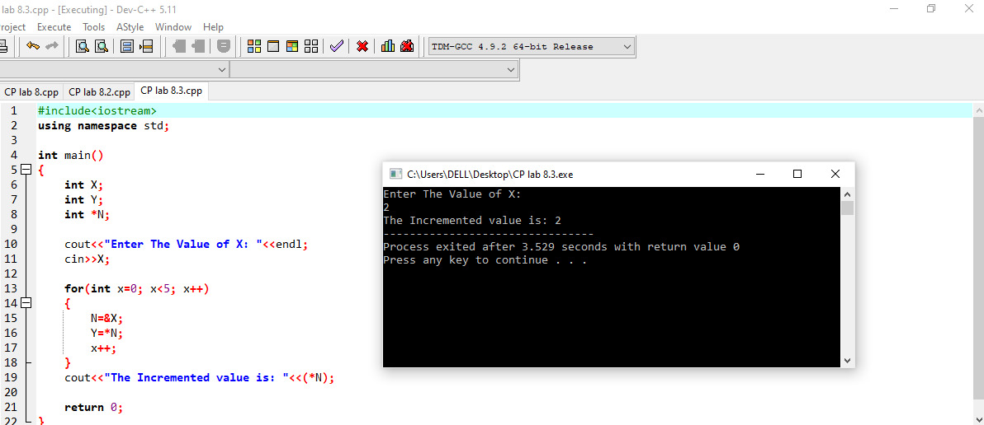**3.** Write a C++ program where you take a value in a variable from use increment that value by 5 using a pointer in a for loop and display its value using pointer.

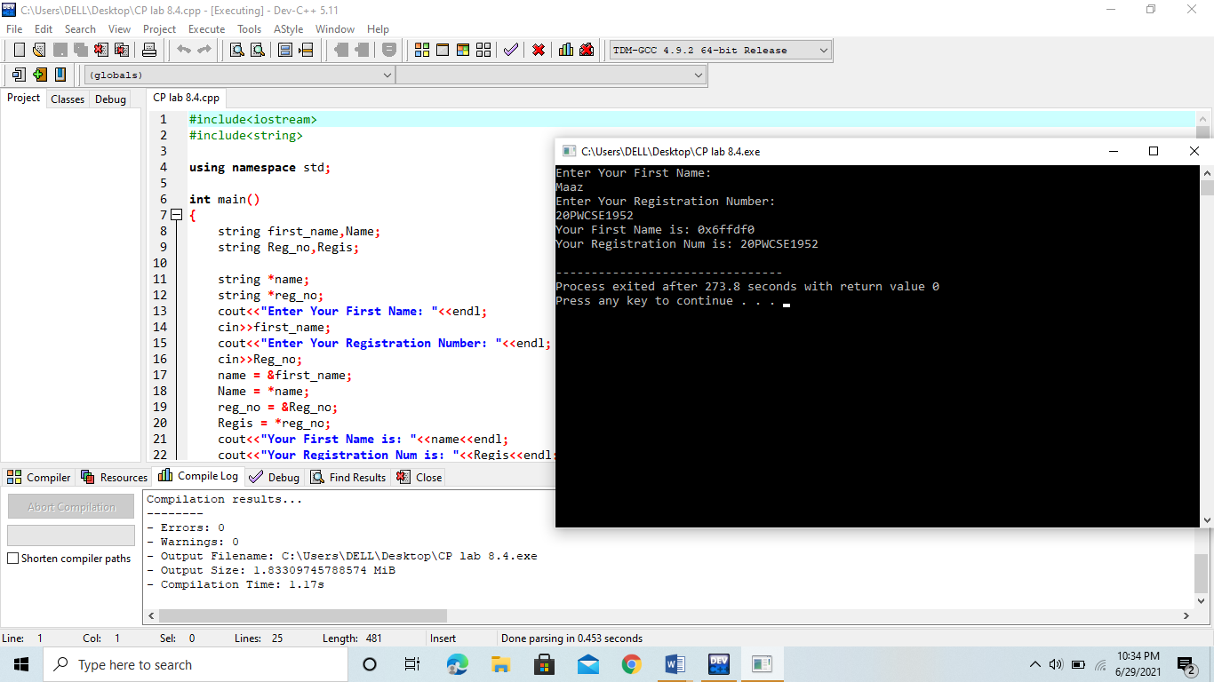**4.** Write a C++ program where you take your first name from user in pointer which points to a string, also in the same way take your registration number from the user in another pointer. And then display both using pointers.

**5.**Display 1 to n numbers using pointer, user must enter the n.

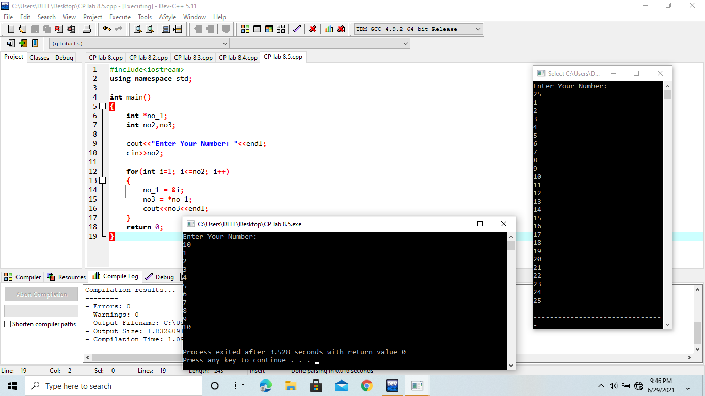

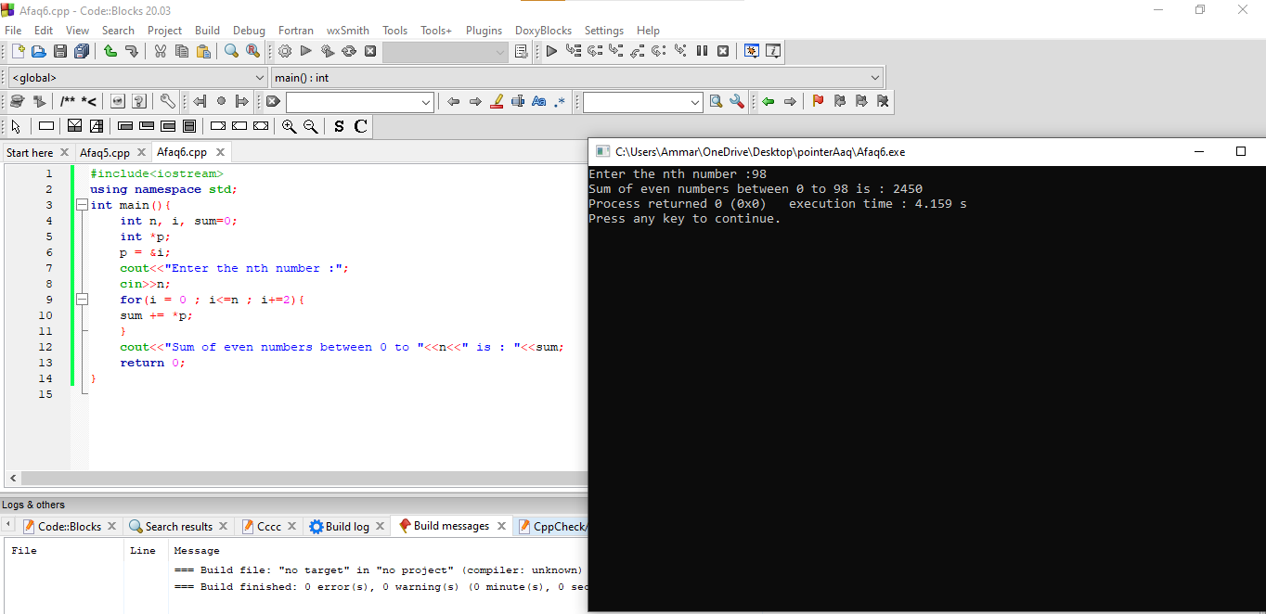**6.** Add even numbers from 1 to n using pointers user must enter n.